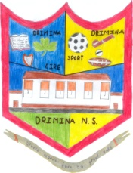
Drimina National School
Calendar
2023/2024

School re-opens for all pupils after summer break: | Wednesday August 30th 2023 at 9.20a.m.
Midterm Break: | School closes on Friday, October 27th 2023.  School re-opens on Monday, November 6th 2023.
Christmas Holidays: | School closes on Friday, December 22nd 2023.  School re-opens Monday, January 8th 2024.
St Brigid’s Day  February Bank Holiday: | School closed on Monday, February 5th 2024.
February Mid-Term Break: | School closed on Thursday February 15th & Friday February 16th 2024.
St Patrick’s Day: | School closed on Monday, March 18th 2024.
Easter Holidays: | School closes on Friday March 22nd 2024.  School re-opens on Monday April 8th 2024.
May Bank Holiday: | School closed on Monday May 6th 2024.
June Bank Holiday: | School closed on Monday June 3rd 2024.
Summer Holidays: | School closes on Friday June 21st 2024.

